Chapter 2 Project 1

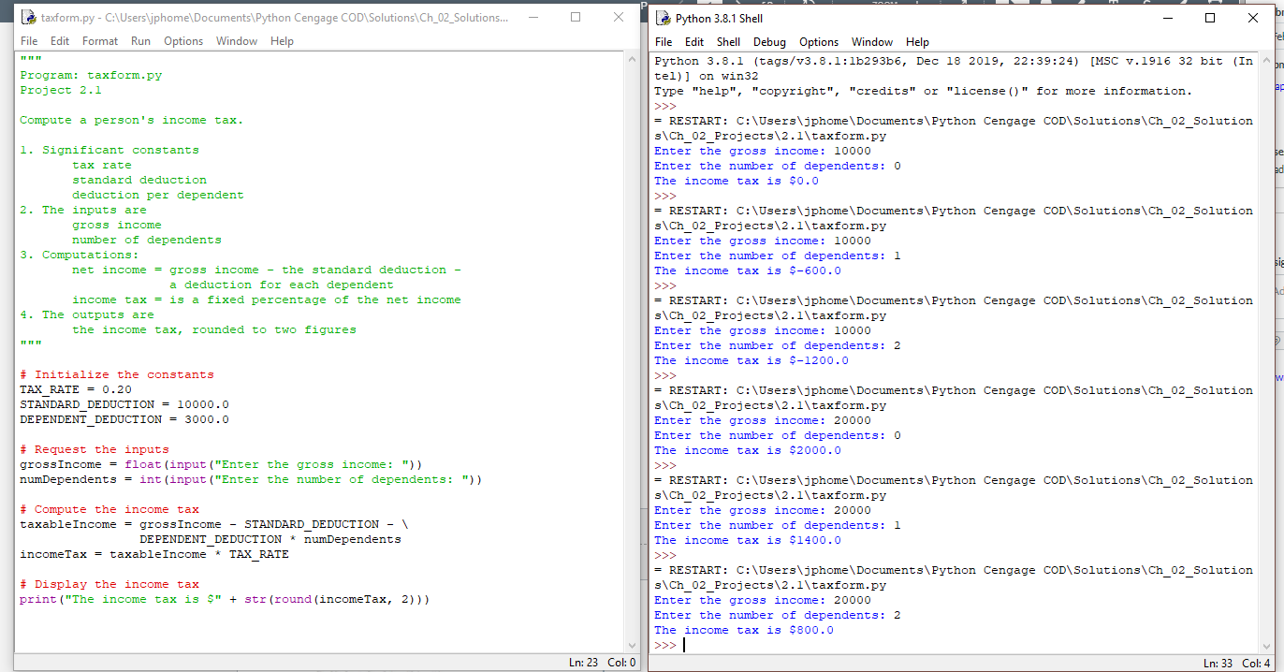

Mr. Powell